Change a record of sex

Information for young people

November 2025

This fact sheet is for young people under 18 years. It will help you find out what you need to know about changing your record of sex.

What does it mean to change a record of sex?

If you were born in Victoria, Australia
With your agreement, your parent(s) or legal guardian(s) may apply to change your record of sex.
This means they ask BDM to change the sex descriptor on your birth certificate.
A ‘sex descriptor’ is the word(s) you use to describe the sex you identify as.
For example, your birth certificate might show ‘male’, but you identify as ‘female’.

If you were born outside Victoria, Australia
With your agreement, your parent(s) or legal guardian(s) may apply to change your record of sex.
This means they can apply for a certificate that will show the sex you identify as.
This certificate is called a recognised details certificate.

What is the process?
You don’t need to have surgery to have your record of sex changed.
BDM accepts most sex descriptors, but there are some the law doesn’t allow. Learn more at bdm.vic.gov.au/sex-descriptors

1. Apply
Your parent(s) or legal guardian(s) need to apply to BDM, asking to change your record of sex.
They can apply:
- Online at bdm.vic.gov.au/change-record-sex’
- Using a paper form and mailing it to BDM
- In person at a Justice Service Centre.
If they need a paper form, they can call 132 842.
They will need to give us some documents.
There is no cost to change a record of sex in Victoria.
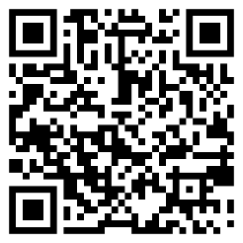 | To fill in the online form, your parent(s) can scan the code or visit  bdm.vic.gov.au/change-record-sex

2. Agree
If you are 12 years of age or older and agree to change your record of sex, you need to tell us you agree to it.
To show that you agree, you’ll need to sign a consent form. The consent form lets BDM know you agree to the sex descriptor listed in the application.
If you are under 12 years old, you can complete the consent form if you want.

3. Review
BDM will look at the information sent in with your application.
This may take some time.
We will contact your parent(s) or legal guardian(s) if we have any questions or need more information.

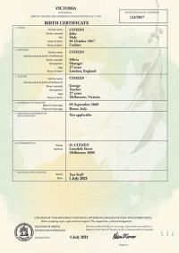
Certificate
If we approve the application, we will send your parent(s) or guardian(s) a certificate.
If you were born in Victoria, you’ll get a new birth certificate. It will show the sex descriptor you have chosen.
If you were born outside Victoria, you’ll get a recognised details certificate. It will show the sex descriptor you have chosen.

4. Delivery times
This process takes time.
We’ll post your certificate to the address you put in your application.
Postage within Australia is free. However, you will need to pay for postage if your delivery address is outside Australia.
Check our current processing times if you want to know more.
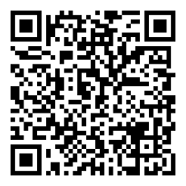 | Scan the code to see how long it may take, or visit  bdm.vic.gov.au/certificate-turnaround-times

5. Update documents
You or your parent(s) or legal guardian(s) may want to update your identity documents and records to show the sex on your new birth certificate or recognised details certificate.
These documents may include:
- Passport
- Learner permit
- School identity cared.
To do this, you or your parent(s) or legal guardian(s) can show your certificate.
For example, show your certificate to your school so they can update their records.
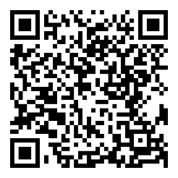 | Scan the code to learn how to update your other identity documents, or visit bdm.vic.gov.au/certificate-turnaround-times

Need help? Contact us

Contact us
A Births, Deaths and Marriages team member can explain the process of changing your record of sex to you.
You can talk to us by:
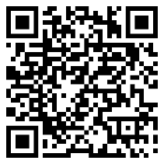 | Scanning the code or visiting bdm.vic.gov.au/contact-us  Calling 132 842  Emailing bdmvictoria@dgs.vic.gov.au

Other help
You can also ask your parent(s) or legal guardian(s) to read more about changing your record of sex at bdm.vic.gov.au/change-record-sex

