Miscarriage, stillbirth or the loss of a newborn

Information for bereaved parents registering their child’s birth

The death of a baby during pregnancy or soon after birth is a difficult time.
We acknowledge the emotional hardship you face at this time.

Stillbirth
A baby is stillborn if they died after having been carried in the womb for 20 weeks or more, or weighing over 400 grams. Your medical practitioner determines this.
While we acknowledge the emotional hardship you’re facing, the law requires you to register the birth.
There’s no fee to do this.
In registering the birth, your child will be remembered in Victoria’s records. It also gives you the option to order a birth certificate in their memory.

Loss of a newborn
If your baby died soon after being born, you will need to register the birth.
A funeral director can register the death for you. The funeral director can also apply on your behalf for a death certificate, if you need one.
In registering the birth, your child will be remembered in Victoria’s records. It also gives you the option to order a birth certificate in their memory.
 | Scan the code to learn what you need to do to register your child, or visit  bdm.vic.gov.au/register-birth-baby-who-died

Types of certificates
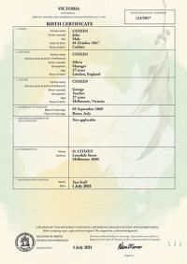
Ordering a birth certificate is optional. You can order one now, or at a later time.
A legal birth certificate (pictured here) can be used for official purposes.
Legal birth certificates are marked as ‘stillborn’ or ‘deceased’
Commemorative birth certificates are decorative keepsakes that commemorate the birth of your child.
They are not legal documents. They can’t be used for official purposes, such as proving identity.
Commemorative birth certificates are not marked as ‘stillborn’ or ‘deceased’.
 | There are fees for ordering legal and commemorative certificates.  To learn more, scan the code or visit bdm.vic.gov.au/register-birth

Early pregnancy loss

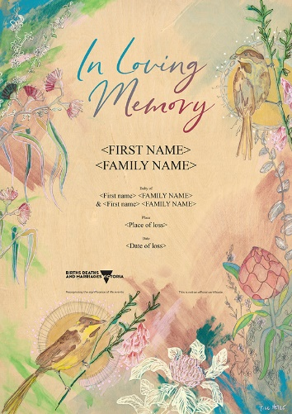
If your baby died in early pregnancy, the birth can’t be registered.
However, you can commemorate an early pregnancy loss with a recognition of early pregnancy loss certificate.
The certificate is free. You may apply at any time. There’s no time limit. You can apply if:
- Your loss took place in Victoria
- The miscarriage was at less than 20 weeks, or if unknown, your baby weighed less than 400g.
The early pregnancy loss certificate is not a legal document.
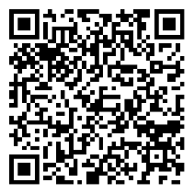 | To learn more about the Early Pregnancy Loss commemorative certificate, scan the code or visit  bdm.vic.gov.au/early-pregnancy-loss-commemorative-certificate

Grief support
Dealing with the death of a loved one is difficult for you, and those closest to you.
If you’re struggling, help is available. Don’t be afraid to ask.
There are organisations who support people experiencing grief.
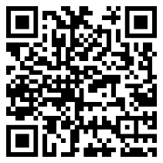 | To find grief support organisations, scan the code or visit  bdm.vic.gov.au/grief-support

Protecting your safety
Your safety is our priority.
If you tell us that you have concerns for your safety, such as family violence, we can protect your information from the other parent.
For example, we don’t have to tell the other parent your address or contact details without your consent.
You will need to provide evidence to support your concerns.
 | To learn more about how we can protect your safety when registering your child, scan the code or visit  bdm.vic.gov.au/protecting-your-safety-bdm

We are here to help you

Contact us
If you need help, you can contact us by:
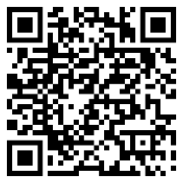 | Scanning the code or visiting bdm.vic.gov.au/contact-us  Calling 132 842 (8am to 4pm Monday to Friday, excluding public holidays)  Emailing bdmvictoria@dgs.vic.gov.au

